Pizza Program Specification

**This is a group project. Groups of a maximum of 4 students will collaborate on the program. The program will then be executed by a different group of students, who will run the program, answer its questions, and print out the pizza recipe as per the instructions in the program. The printed pizza recipe will then be followed exactly as stated by the pizza chef. The group who wrote the program gets to eat pizza that is produced by following their program’s recipe.**

**Objective:** Write a program that interactively allows users to specify the ingredients to go on a pizza.

**Specification:**  Create a Java Console Application that simulate the operations of placing a pizza order. The order of items on the pizza is important. The program must ask the user what ingredient is next and must allow the user to choose the item from a list of specified ingredients, and must also prompt the user for item quantity from within a reasonable range of permitted values. After each ingredient the program must ask if the user is finished. However, the pizza cannot contain more than a maximum of 8 different ingredients, including the crust, the sauce, and the cheese. When the program is complete, it must print out a recipe that will be followed by the pizza chef. All Pizza Ingredients in the list below must be listed in your program. The user MUST be allowed to choose from among all items and quantities. However, error detection and error messages are allowed. Error messages could be used to exclude items that your team does not wish to allow on its pizza. *Don’t forget to specify in your recipe that the pizza is to be cooked, or it will not be.*

**Language:** The program must be written using the programming language you are learning in this class.

**Pizza Ingredients:**

|  |  |  |  |
| --- | --- | --- | --- |
| **Item #** | **Category** | **Measure** | **Maximum Quantity** |
| **1a OR** | **Crust - regular** | **each** | **one** |
| **1b** | **Crust-gluten-free** | **each** | **one** |
| **2** | **Red Sauce** | **¼ cup** | **two** |
| **3** | **Pizza cheese** | **¼ cup** | **two** |
| **4** | **Diced onion** | **1/8 cup** | **two** |
| **5** | **Diced green pepper** | **1/8 cup** | **two** |
| **6** | **Pepperoni** | **2 pieces** | **Four** |
| **7** | **Sliced mushroom** | **1/8 cup** | **Two** |
| **8** | **Diced jalapenos** | **1/8 cup** | **Two** |
| **9** | **Sardines** | **each** | **Four** |
| **10** | **Pineapple Chunks** | **2 pieces** | **Four** |
| **11** | **Tofu** | **¼ cup** | **Two** |
| **12** | **Ham Chunks** | **4 pieces** | **Four** |
| **13** | **Dry red pepper** | **Generous sprinkle** | **Four** |
| **14** | **Dried basil** | **Generous sprinkle** | **Two** |

**Cooking: Pizza is to be appropriately cooked until crust is cooked and topping is fully warmed.**

Submit your program documentation including analysis, design, coding and testing (screen captures). Zip up your entire Java project folder in NetBeans. Follow the project link in Blackboard to upload your group work.

Prof. Margaret Hvatum and I will be the pizza chef. We will execute your program code and follow the recipe and cooking instructions your program gives to make the pizza. If your program runs successfully without errors and the pizza gets baked, then you and your team get to eat the pizza and your program will be automatically entered into our drawing. Winning prices include gift cards, T-shirts, hoodies, backpacks, and more.

The following are screen captures for ordering a regular crust cheese pepperoni pizza with dry basil: 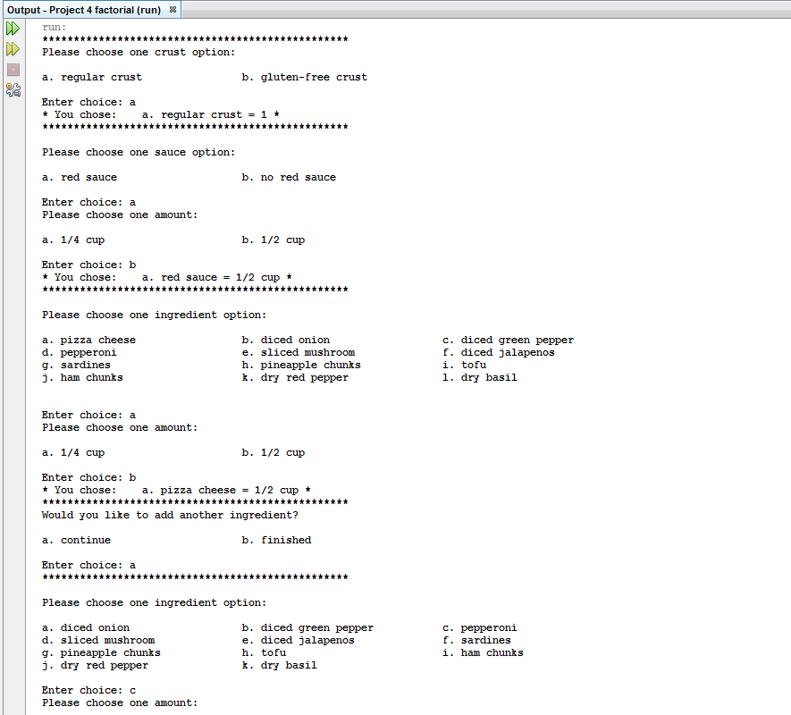

Screen caputre to be constinued on the following page:

